**Poynting’s Python Society Aut9 2022:**

**Curve Fitting**

Curve fitting is all about finding the best function to match some data. These functions typically have variability on unknown parameters, and so once we’ve chosen a family of functions to model our data on, we need to determine the actual values of the parameters that best fits our data.

Today, we’ll be trying to fit some simulated data, shown below, to a family of functions of the form:

$$f\left(x;a,b\right)=ax e^{-bx^{2}}$$

Here, a ‘family’ of functions just refers to the fact that we could get lots of different functions by choosing different values of parameters $a$ and $b$.

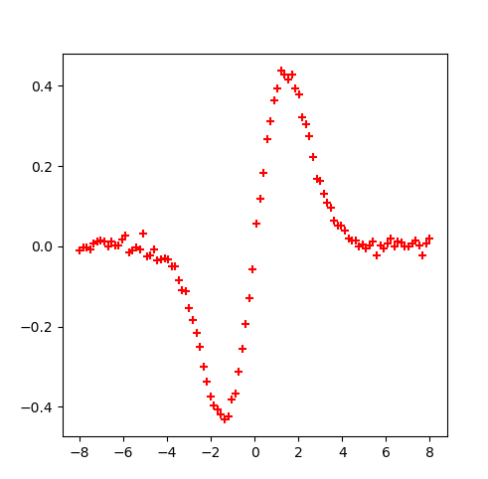

Figure : Some data that we want to fit too

Our job is to find the *specific* values of $a$ and $b$ that best fit the data above.

To do this, we use a least-squares fitting function from SciPy called *curve_fit*, the documentation for which is available [here](https://docs.scipy.org/doc/scipy/reference/generated/scipy.optimize.curve_fit.html).

This might be the first time you’ve had to read any documentation, so before we begin coding, I’ll just explain how *I* read documentation.

**Reading Documentation**

Here is a screenshot of the documentation of the curve_fit function taken from the website:

All that information may seem a bit scary, but we don’t need to read it all! The most important bits of all documentation are the following:

1. **The function’s *DESCRIPTION***
2. **It’s *INPUTS*** (or parameters)
3. **It’s *OUTPUTS*** (which you’ll need to scroll down for!)

The first thing we learn about curve_fit is that it ‘uses non-linear least squares to a fit a function, f, to data’ – this is good, we want to fit data to a model function!

Secondly, the first 3 parameters (or inputs) tell us what the function wants. It wants:

1. a model function f(x, …) – this needs to be a *callable*, which is basically just a function that we can *call* – and it’ll depend on some parameters (e.g. a and b from above)
2. some xdata
3. some ydata – this will be the data we’ll be fitting! (and it asks for them in *array_like* form, we’ll just use numpy arrays).

Some functions have lots of inputs, but often we don’t need to use all of them. You’ll notice that curve_fit has a lot of inputs which take default values, and often we can just ignore them.

Scrolling down, we’ll also learn about curve_fit’s outputs. Don’t be put off by how far you have to scroll down – just look for where it says ‘outputs’ or ‘returns’. Most important to use are the two arrays,

1. popt – an array of optimal values for the parameters (so that the error between the model function and the data is minimised)
2. pcov – a 2d array with estimated errors – you’ll only ever have to use the items on the diagonal, which represent the estimated variances on the optimal parameter values.

Most documentation will also have some examples showing the functions in action, which can be super useful too!

***Big Coding Tip:*** Being able to read documentation is really important, as it’ll allow you to use functions that other people have written. Often you don’t need to understand how a particular function works, only how to *use* it, and this is what documentation is for – teaching you how to *use* other people’s code.

Also, this takes practice! Just try and remember that you only really need three bits of information from documentation: its *description*, its *inputs* and its *outputs.*

**Fitting to $axe^{-bx^{2}}$**

Now we’re going to walk you through the process of fitting the above data to our model function $f\left(x\right)=axe^{-bx^{2}}$. Ultimately, we want to plot the data shown in Fig. 1, overlayed with a nice smooth curve that fits the data. You should have been sent a .csv file containing all the data points, let a demo know if not or send me and email at [hga946@student.bham.ac.uk](mailto:hga946@student.bham.ac.uk).

Let’s ***plan:***

First things first, import some libraries:

1. Import numpy, matplotlib and scipy.optimize.

Then, let’s make sure we can read the .csv file into a numpy array:

1. Read in the .csv file to a numpy array

To check we’ve loaded in it right,

1. Try plotting the data – it should look like Figure 1.

Now to do the fitting, since curve_fit needs a callable f(x, …) (which acts as the model function) we also need to:

1. Write a function model_function(x,a,b)that takes x as a dependent variable, as well as parameters a and b, and returns $axe^{-bx^{2}}.$

Once we’ve done this we can:

1. Call curve_fit, to calculate the optimal values of a and b

Finally:

1. Plot the data and overlay with a nice smooth curve that represents the best fit curve, using the parameter values found in part 4.

That’s the overall plan, but let’s go into a bit more detail for each step…

Firstly, step 1, remember we load in libraries by something like the following:

For step 2, and loading in .csv files, firstly make sure you’re in the same working directory as the ‘simulated_data.csv’ file, and then call:

Being in the ‘same working directory’ is equivalent to saving the .csv and your .py file in the same folder. The ‘delimiter’ parameter here tells numpy what separates values in the .csv, so it knows what format to put the ‘data’ numpy array into.

*Side note:* The function np.savetxt (…) has the opposite effect of np.loadtxt, it will save a numpy array to a given file and I used it to create the ‘simulated_data.csv’ file that you’re using. The documentation for [np.savetxt](https://numpy.org/doc/stable/reference/generated/numpy.savetxt.html) and [np.loadtxt](https://numpy.org/doc/stable/reference/generated/numpy.loadtxt.html).

For steps 3 and 5, here’s a template for plotting with matplotlib:

For step 4, just try calling curve_fit(…), making sure you put the inputs in the right places (as per the documentation) If it doesn’t work, see if you can understand the error it produces.

Ultimately, you should be able to plot something like this:

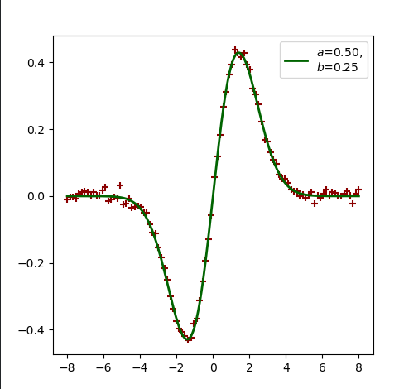

Figure 2: Data with best fit curve overlayed



Check you get $a=0.5$, $b=0.25$.

In case you’re interested, the reason your best fit doesn’t fit the curve perfectly is because I added a little noise in the y-direction to create this data :). Adding ‘noise’ is equivalent to adding a scaled normal distribution to each y-value – I called something like this:

